Coronavirus Facts  Coronaviruses are a large family of viruses which may cause respiratory infections ranging from the common cold to more severe diseases.  Infection  An infected person can spread the virus to a healthy person through the eye, nose and mouth or through droplets produced on coughing or sneezing; close contact with an infected person; contact with contaminated surfaces, objects or personal items.  Symptoms  The general symptoms include fever, cough, difficulty with breathing, sore throat.  Prevention  To prevent the spread of the virus:  Wash your hands often with soap & water for at least 20 seconds. Use an alcohol-based hand sanitizer if you cannot wash your hands with water.  Keep a safe social distance (at least 1½ m) from other people.  Avoid touching your mouth, eyes & nose.  Use tissue paper when coughing & sneezing, then throw it in a bin.  Regularly disinfect frequently touched items, eg cellphone, cards, car keys, keyboards, etc.  Consult your doctor if not feeling well & stay at home to recover fully.  Use the flexed elbow, foot bump or wave to greet instead of a handshake.  Wear a face mask, especially the cloth face mask, when in public. |  | Contact Numbers  [First Name Surname]  Covid-19 Compliance Officer  [Name of Company]  Office Tel No.: . . . . . . . . . . . . . . . .  E-mail: . . . . . . . . . . . . . . . . . . . . . .  Cell Phone No.:. . . . . . . . . . . . . . . .  Covid-19 Telephone No’s  Hotline: 0800 029 999  WhatsApp No.: 0600 12 3456  Websites  The National Dept of Health  www.health.gov.za  The National Institute of Communicable Diseases  https://www.nicd.ac.za/  The National Institute for Occupational Health  http://www.nioh.ac.za |  | Company Name & Logo  Coronavirus (Covid-19)  Information  for  Employees
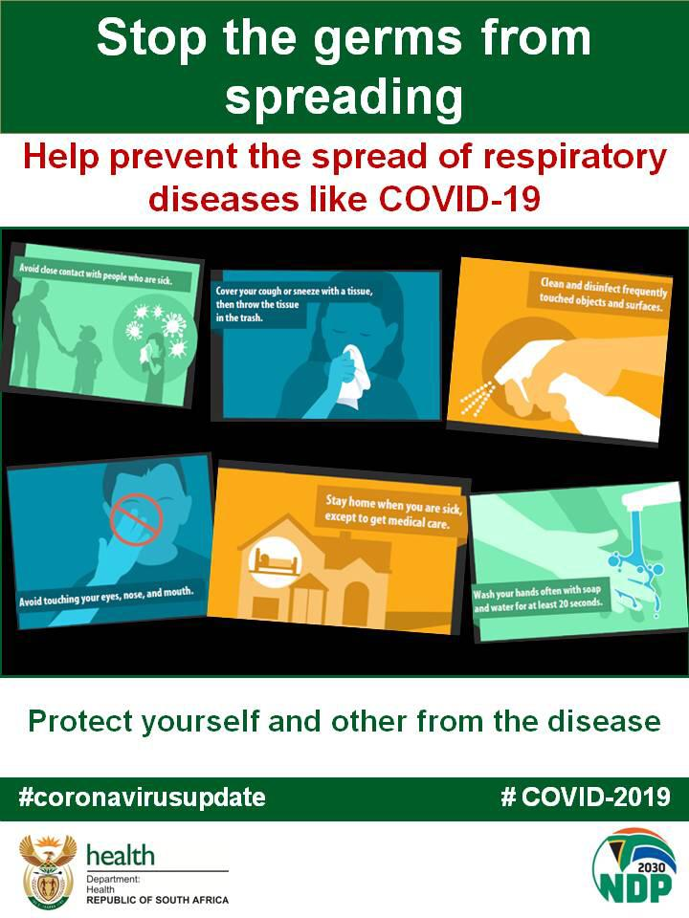 |  | 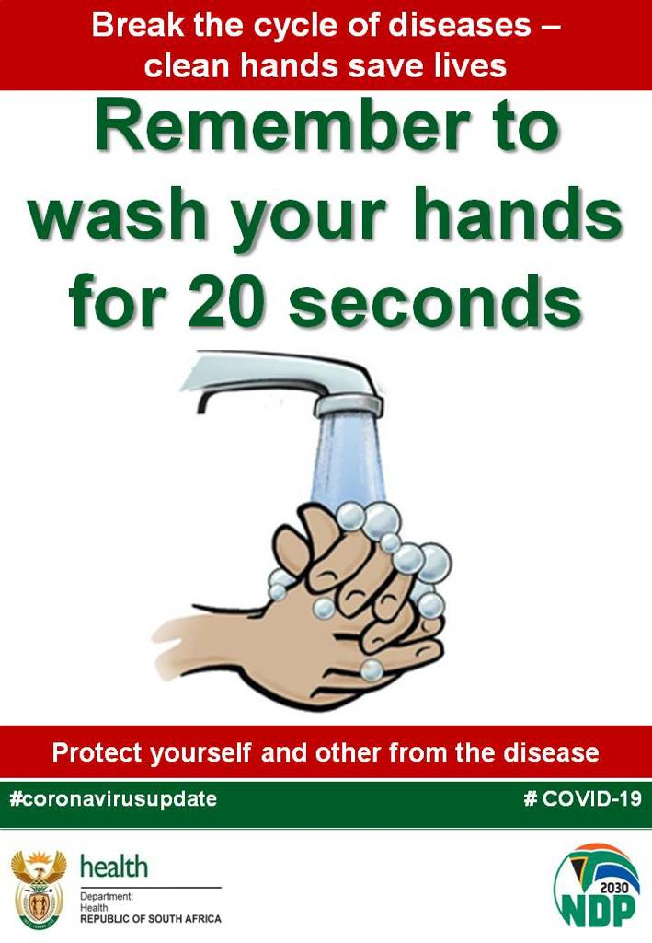  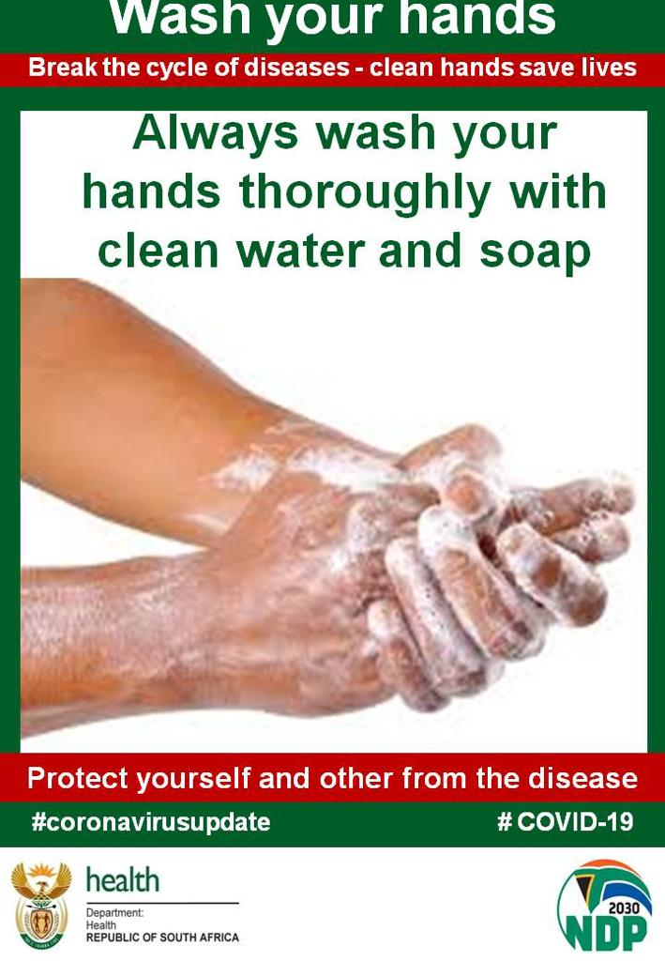 |  | 